Department | AIDS
Course Code / Course Name | DSA0602/ Data Handling and Visualization
Experiment | Data Visualization using R
Name | YASHIKA.R
Register Number | 192525102
Date | 10/10/2026
Day | Saturday
Set 18: Product Inventory Management

1 . Bar chart — Product quantities
Aim: To compare the available quantities of different products.
Algorithm:
- Create a data frame of product names, quantities, and prices.
- Map product names to the x-axis and quantity to the y-axis.
- Draw a bar chart with labels and a title.
Code:
if (!requireNamespace("ggplot2", quietly = TRUE))
install.packages("ggplot2", type = "binary")
library(ggplot2)
inventory <- data.frame(
ID = 1:3,
Product = c("Product A", "Product B", "Product C"),
Quantity = c(250, 175, 300),
Price = c(20, 15, 18)
)
ggplot(inventory, aes(x = Product, y = Quantity, fill = Product)) +
geom_col() +
labs(title = "Product Inventory Quantities",
x = "Product Name", y = "Quantity Available") +
theme_minimal() +
theme(legend.position = "none")
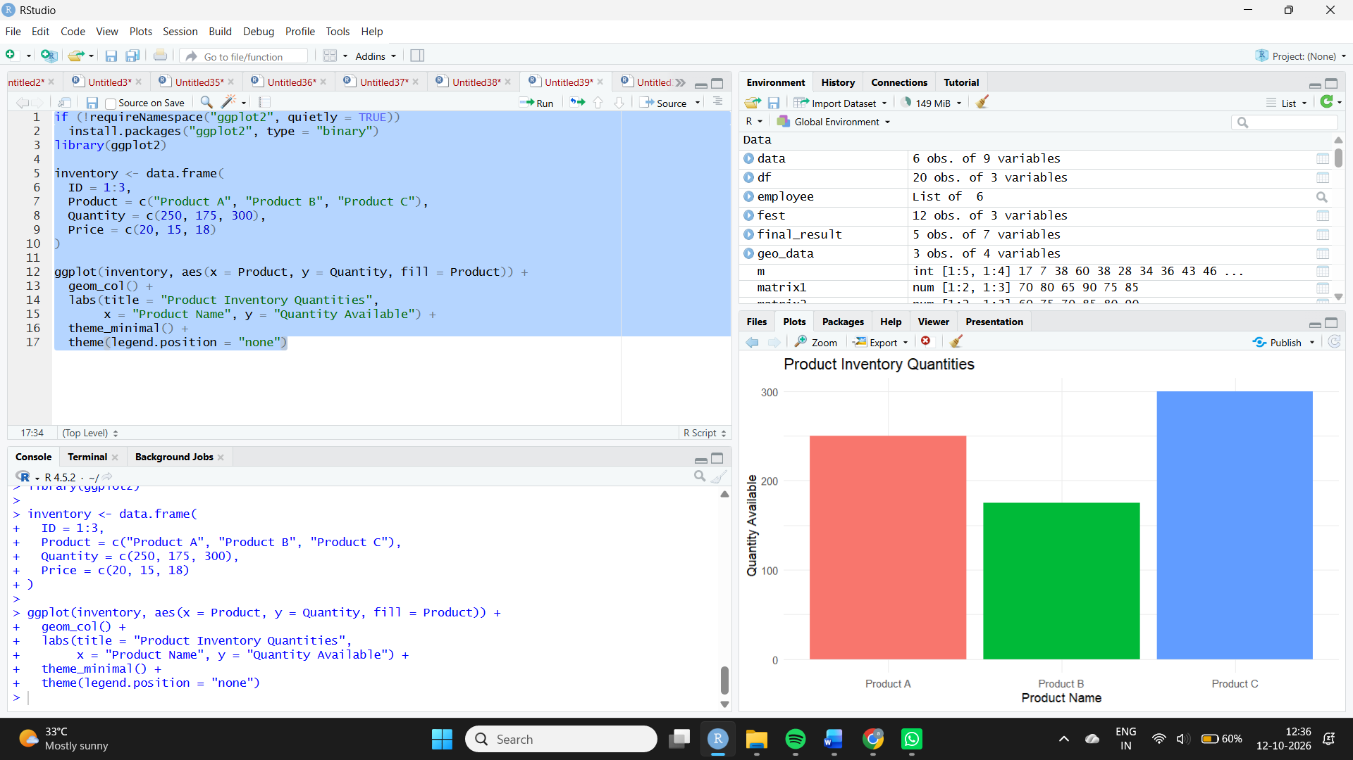
Observation: Product C has the highest inventory with 300 units, while Product B has the lowest with 175 units.
2. Stacked bar chart — Quantity by product category
Aim: To show how product quantities are distributed across product categories using a stacked bar chart.
Algorithm:
- Add a category column to the inventory dataset.
- Group the data by product and category.
- Map category to the fill aesthetic.
- Draw a stacked bar chart with a legend.
Code:
inventory_cat <- data.frame(
Product = c("Product A", "Product A",
"Product B", "Product B",
"Product C", "Product C"),
Category = c("Electronics", "Accessories",
"Electronics", "Accessories",
"Electronics", "Accessories"),
Quantity = c(150, 100, 100, 75, 180, 120)
)

ggplot(inventory_cat,
aes(x = Product, y = Quantity, fill = Category)) +
geom_col() +
labs(title = "Product Quantity by Category",
x = "Product", y = "Quantity", fill = "Category") +
theme_minimal()
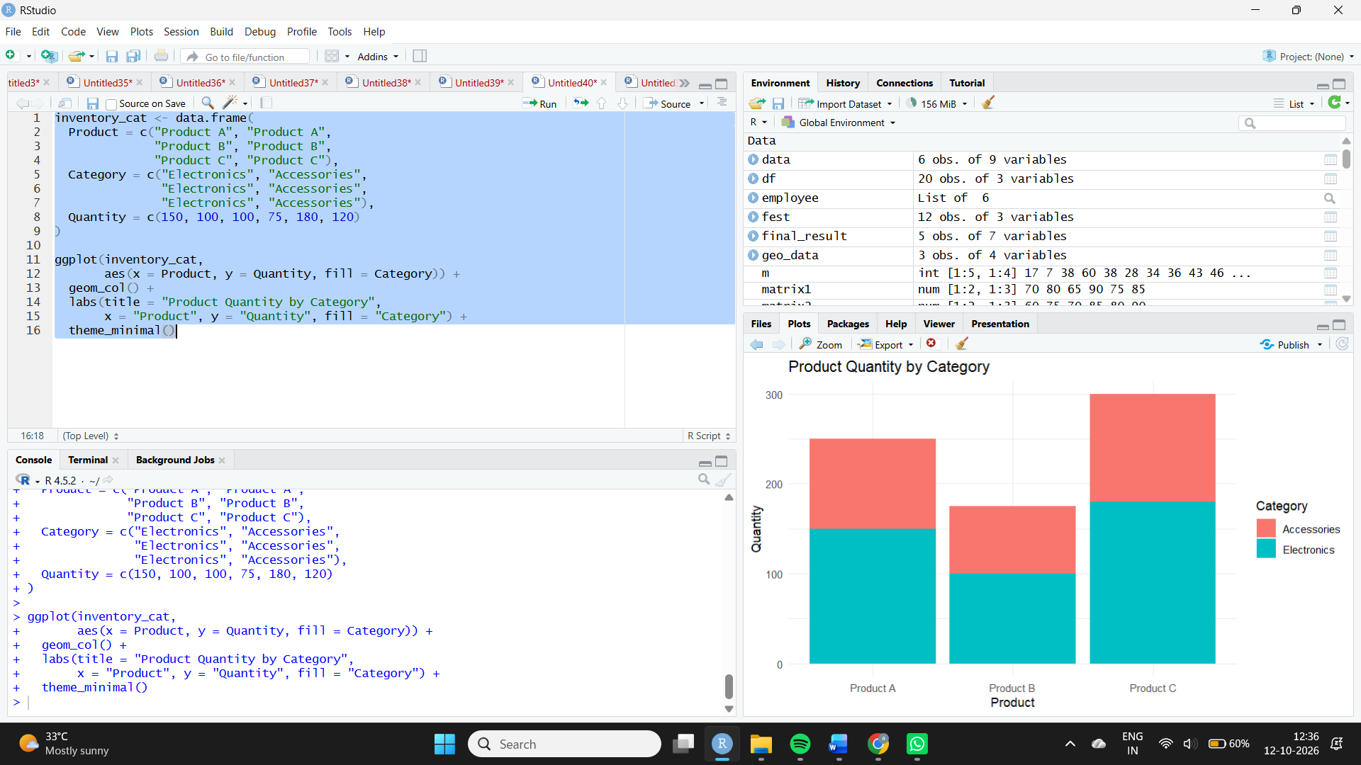
Observation: Product C has the largest total quantity. The stacked segments show the contribution of each category. The category-level quantities are illustrative allocations because the original dataset does not specify product categories.

3. Inventory table
Aim: To display the ID, product name, available quantity, and price of each product.
Algorithm:
- Store product data in a data frame.
- Assign column headings.
- Print the inventory table.
Code:
print(inventory)
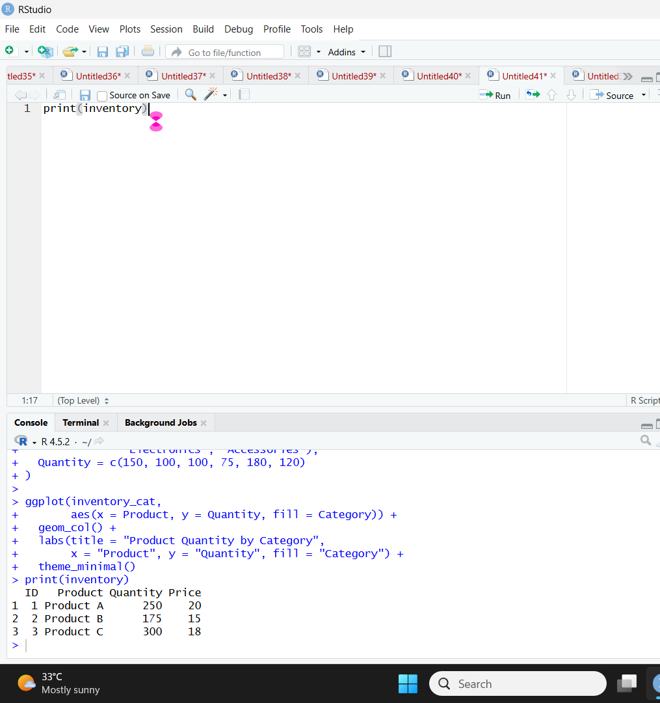
Observation: The table displays all inventory records. Product C has the highest quantity, and Product A has the highest unit price at $20.
4. Tableau dashboard
Aim: To combine product quantity charts and the inventory table into an interactive dashboard.
Algorithm:
- Import the inventory dataset into Tableau.
- Create a quantity bar chart.
- Create a stacked bar chart using product and category.
- Create a product inventory table.
- Combine the worksheets and add product/category filters.
Procedure in Tableau:
- Connect Tableau to the inventory CSV or Excel file.
- For the bar chart, place Product on Columns and SUM(Quantity) on Rows.
- For the stacked chart, use Product on Columns, SUM(Quantity) on Rows, and Category on Color. Use a dataset with category-level quantities.
- For the table, display Product ID, Product Name, Quantity Available, and Price.
- Create a dashboard and drag in all three worksheets.
- Add Product and Category filters and configure chart selections to filter the other views.
Observation: The dashboard supports comparison of product quantities, category contributions, and individual inventory details.

